Tropical Storm Helene
5:00 PM National Weather Service Advisory on September 24, 2024

The City of Naples has issued a Local State of Emergency in response to Tropical Storm Helene, following the emergency declarations by Governor DeSantis and the Collier County Board of County Commissioners. Helene is forecasted to strengthen into a major hurricane by early Thursday, with storm surge and coastal flooding posing significant threats to the City of Naples.
According to the 5:00 PM National Weather Service advisory, the storm is approximately 150 miles south of the western tip of Cuba, moving west-northwest at around 12 mph, with maximum sustained winds of 50 mph. A Tropical Storm Warning and Storm Surge Warning have been issued for coastal Collier County and surrounding areas. The National Weather Service anticipates our area will receive tropical storm force winds and storm surge from 3-5 feet. Storm impacts are expected to begin on Wednesday evening. Later this evening and overnight, increasingly dangerous beach and boating conditions will develop in our area; this includes wave heights of 5-8 feet. We strongly recommend people stay out of the water to ensure their safety. Our local beaches do not have lifeguards on duty.
- A Storm Surge Warning means there is a danger of life-threatening inundation, from rising water moving inland from the coastline, during the next 36 hours.
- A Tropical Storm Warning means that tropical storm conditions are expected somewhere within the warning area within the next 36 hours.
We urge all residents to stay informed by regularly checking local news outlets, the National Hurricane Center, and the National Weather Service - Miami Office.

For your safety and the safety of others, please plan to remain indoors during the storm’s impact, avoid flooded or impassable roadways, and be cautious of debris on the streets.

Important Reminders:
- Never walk or drive in the flood waters. Many people are killed by driving or walking on roads and bridges that are covered by water. Even though the water might look only inches deep, it could be much deeper and have strong currents. It takes only two feet of water to carry a car away, and only six inches of swiftly moving water to sweep a person off their feet.
- Find an alternate route around the flooded area. If you are approaching a flooded roadway, turn around and take an alternate route, even though vehicles in front of you may have passed through the high water.
- Don't assume your vehicle is safe. High water in streets and intersections will quickly stall motor vehicles. Most trucks, four-wheel drives, and sport utility vehicles are susceptible to being swept away by high water.
- Never stay with your car in a flooded area. If your car stalls, abandon it immediately and climb to higher ground. Many deaths have resulted from individuals attempting to move stalled vehicles.
- Safety First: Do not attempt to surf, water ride, or engage in similar activities on medians, easements, and roadways. This is extremely dangerous and may result in police enforcement actions.
- Residents in flood-prone or low-lying areas should take extra precautions and plan to stay inland beginning Wednesday evening and during the storm to ensure their safety.
Horticulture, Solid Waste, and Recycling: Storm Preparedness Tips
- Do not begin construction projects that produce debris.
- Please ensure all horticultural debris is secured on your property and not placed in the public right of way, as tropical-storm-force winds can turn debris into dangerous projectiles. Additionally, placing vegetation trimmings in the right of way can block stormwater drains, leading to flooding and other hazards.
- Please secure your recycling and trash carts. Depending on the severity of the storm, the City’s regular collection schedule may be impacted. The City will notify the public if services are temporarily suspended.
If you encounter debris in roadways, traffic light outages, or clogged storm drains, please call (239) 213-3000. For issues regarding your water or sewer service, call (239) 213-4745. If you are in an emergency situation, call 9-1-1. For all other non-emergencies, call (239) 213-3000. To report a power outage, contact FPL at 1-866-263-9186 or visit www.FPL.com.

Your safety is our top priority. Please take all necessary precautions and stay informed as we navigate through this weather event together.

Stay safe, Naples.

  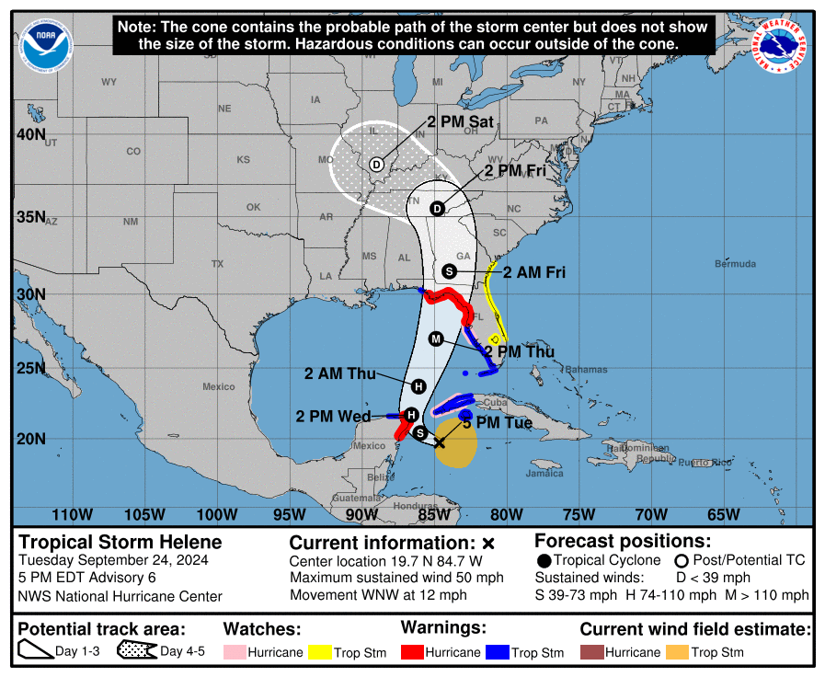
  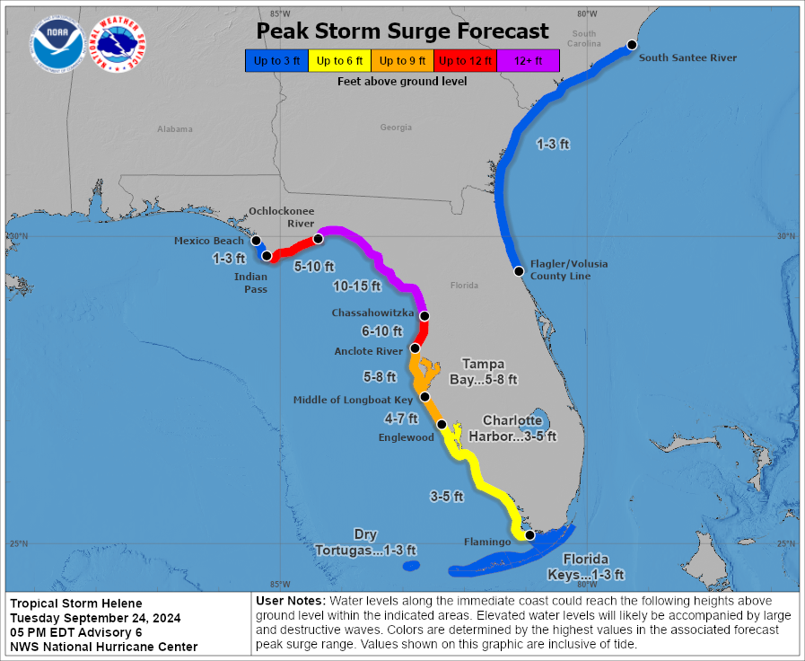
  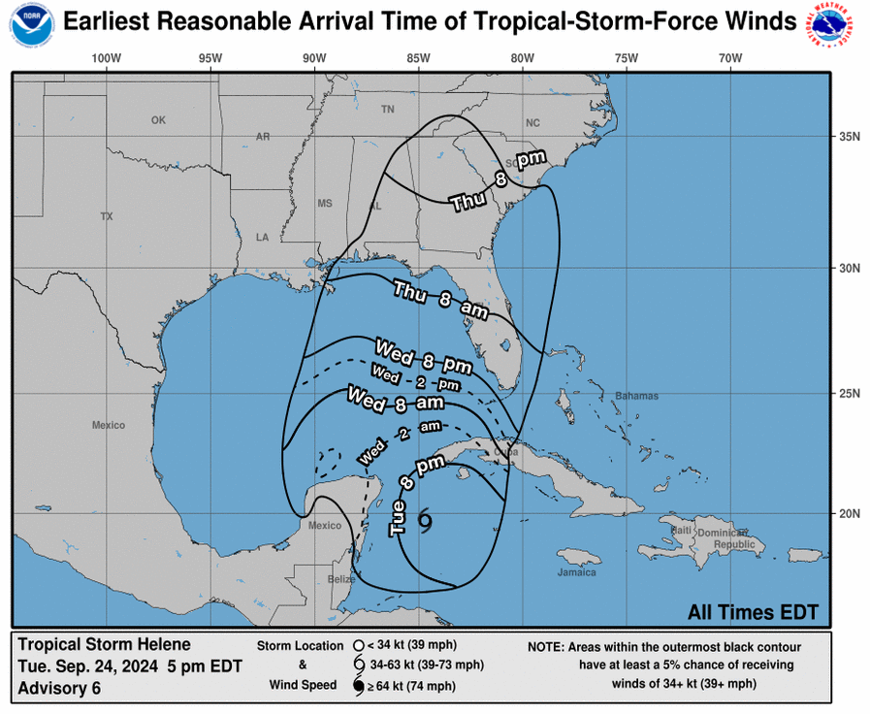
  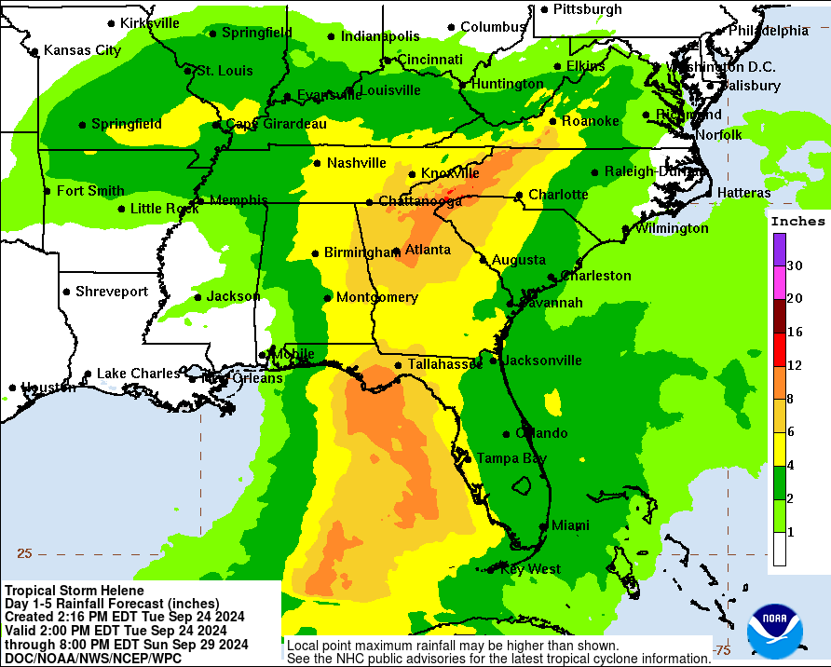



  
  National Hurricane Center Website
  City of Naples Hurricane Preparedness Website
  CodeRed Alerts: Sign-up NOW
  View your evacuation zone
  Emergency Supply Checklist
  2024 Family Hurricane Preparedness Guide
  Collier County Special Needs Program
  Collier County Emergency Management & Shelter Information
  American Red Cross Shelter Directory
